Department of Electrical and Computer Engineering

COEN 6501 Dec. 12, 2015

Answer all Questions. All Questions carry equal marks

Exam Duration 3 hour

No books, papers are allowed. Lecturer: Asim J. Al-Khalili

===============================================================

Question 1

1. Implement F1 (A,B,C) using look up table. You may minimize F if you want.

**F1 (A,B,C) = A’B C’ + A B’ C’ + A B C+ A’ B’ C**

1. How you would implement F2, optimally, given a free choice of using all kind of tables?

**F2 (A,B.C,D,E,F,G,H,K) = ABCD + F + B’GH + A’EC’K**

Calculate Area and delay

Question 2

Design a hardware using carry save adder arrays to calculate Z.  
 **Z = 0.25 XY + 1  
X,Y**  are unsigned 4-bit binary numbers**.** Evaluate your design in terms of speed and area

**Question 3**

Design a synchronous sequential delay line circuit, that receives serial data on line X, and produces a serial output, Z, equal to the input but delayed by 3 clock cycles . A separate mechanism will reset the circuit.

Start with State diagram and follow standard FSM design procedure to arrive at the circuit diagram. Use D-Flip Flop for your implementation.

**Delay Circuit**

X

CLK

**Z**

**Fig.1**

**Question 4**

**a.** Identify all the paths in the circuit shown in the Fig. 2 below.

**b.** Determine maximum speed of operation at typical conditions.

Timing parameters for all components are listed in Table 1.

**c.** At the maximum speed of operation, determine the **slack time** for the **setup time and hold time** at the **K-input** of Flip-Flop **U5**. Is there any violation?

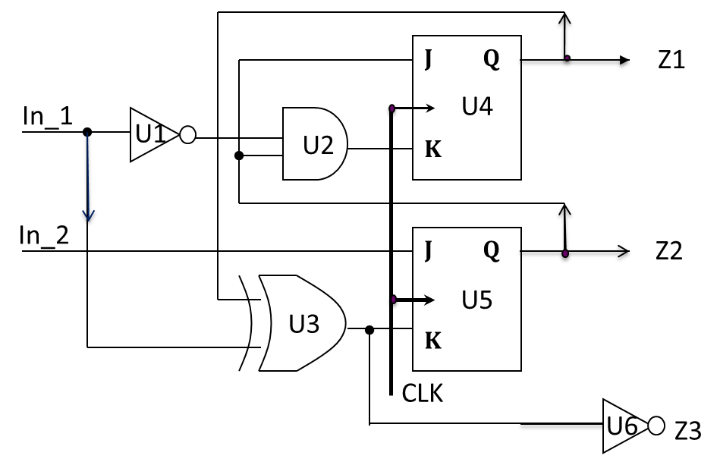

**Fig. 2**

|  |  |  |  |  |
| --- | --- | --- | --- | --- |
| Component | Tp (ns) | Input Loading (UL) | K1  **ns/UL** | K2 ns/fanout |
| Inverter | 0.1 | 1 | 0.1 | 0.08 |
| XOR(2input) | 0.20 | 2 | 0.05 | 0.14 |
| AND (2 input) | 0.4 | 1.5 | 0.12 | 0.18 |
| Flip Flop, ↑, (CK to Q)  **Tsu=1 ns, th = 0.5ns** | 1.5 | 2 | 0.15 | 0.2 |

**Table 1**

**Question 5**

a. The Circuit shown in Fig. 2 operates at a frequency 50 MHz. Signal A and B arrive at **-∞.** Determine the arrival time, the required time and the slack time at points **F**.

b. Determine the maximum clock frequency, considering worst case scenario.

The circuit is implemented on a die, packaged in a ceramic DIP with a thermal resis­tance of 30oC/W. Power consumption of the chip is 1.5 W with room temp at 25 oC. Fanout loading is neglected. Voltage variation can be **± %5**. Use Table 2 parameters.

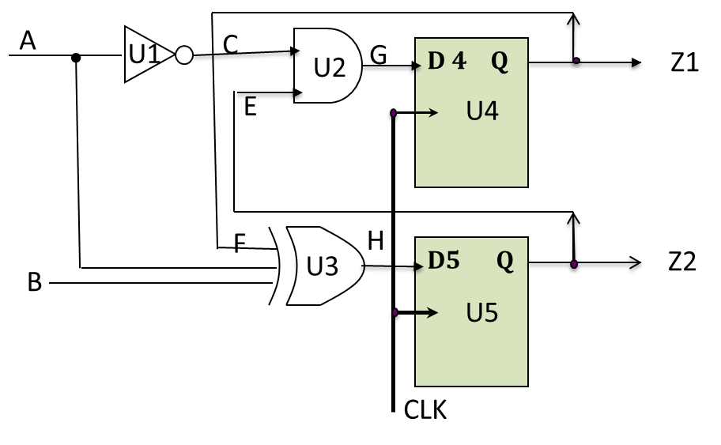

**Fig. 2**

 , K’ = KT * KV *K p  KT = 

TJ = Tamb + Φ Ja * Pd KV =  , KP = 1+ 0.01 * fP

|  |  |  |  |
| --- | --- | --- | --- |
| Component | Tp (ns) | Input Loading (UL) | K1 ns/UL |
| AND/(2input) | 0.2 | 1 | 0.15 |
| INV | 0.1 | 2 | 0.25 |
| XOR (3 input) | 0.4 | 3 | 0.35 |
| Flip Flop, ↑, (CLK to Q)  **Tsu=1 ns, th = 0.5ns , tskew=2ns** | 2 | 4 | 0.45 |

**Table 2**

**Question 6**

Design a bit comparator shown in Fig 3, then using iterative method design an 8-bit comparator shown in Fig. 4.

Using VHDL, and the bit comparator as a component, write the code for an 8-bit comparator.

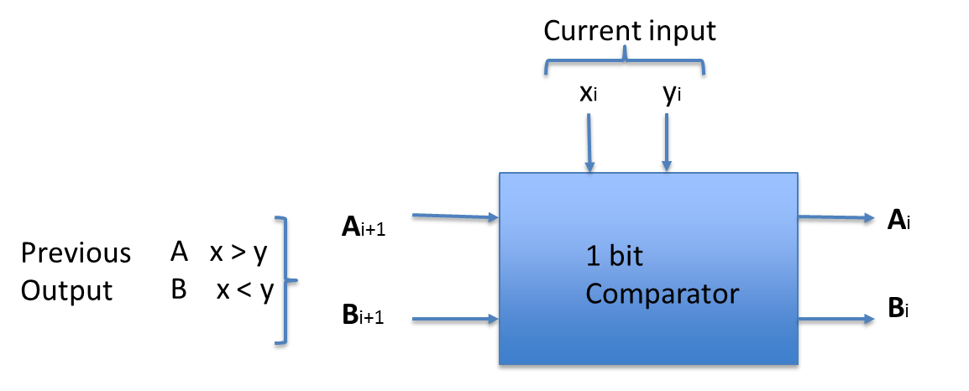

**Fig. 3**

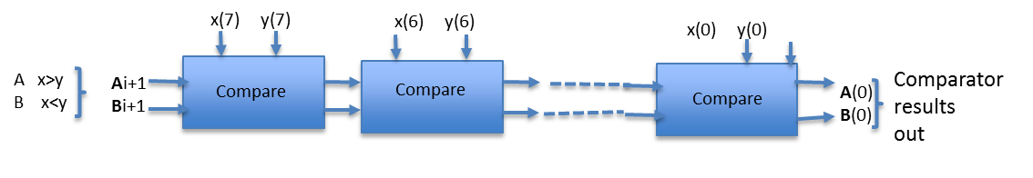

**Fig. 4**

=====================================================================

**Appendix A**

**1. tcs,max < tCQmin + tCLmin + tsu.min**

**2. Tmin ≥ tCQmax + tCLmax+ tsUmaxR2 –tcsmin**

**3. thmaxR2 < tCQmin + tCLmin - tcsmax**

**tCL = tLogic + tinterconnec**